**Final Report Fighters**

Abdul Moiz Zahid,

Introduction:

As my final project is had made a game. My game is simple and easy. So basically, the game is two player games, so two players can play the game at same time. There are two characters introduced in the game one is Warrior, and the other character is Wizard. The theme of game is quite simple, both characters are going to fight each other, so one will defeat the other. The player who wins get the point and the game starts again as a loop.

**Libraries:**

I have used one library in my game code which is pygame library and there are some modules I have used such as

* Mixer:

Pygame module used for loading and playing sounds.

* Display:

Pygame module used to control the display of window and screen.

* Time:

Pygame module used for monitoring time.

* Image:

Pygame module used for image transfer.

* Font:

Pygame module used for loading and rendering fonts.

* Transform:

Pygame module used to transform surface.

* Draw:

Pygame module used for drawing shapes.

* Event:

Pygame module used for interacting with events.

* Key:

Pygame module used to work with the keyboard.

**Game window:**

I created the game window by assigning value to screen height and width and the function (set_ mode) will create a game window for me and it will take two initial arguments as you can see below. I have given this window a title Fighters by using (set_ caption). So, line 8 to 12 describe the creating of game window.

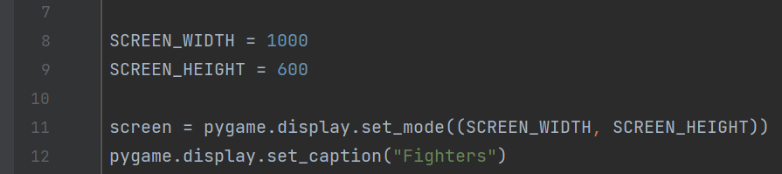

**Game Loop:**

The game loop will allow the game to consciously run, to take actions, draw the players and every thing on the screen until the we actually choose to EXIT. So this is going to be with declaring a variable and then setting up the loop based on that variable. I took the variable run and set that variable to true and I added my while loop to it. As while run is true, so we execute all the below it.

**Event:**

I am using event to exit while loop, so I used the available event and an event for specific moment which is execute when you click on the X on the top right conner on the game window. As we know the while loop is running on the variable run which is assigned True so, I can’t exit the screen for exiting the loop I have changed the variable run to False.

**Background Image:**

I have assigned variable (bg_image) for this and I used load command and here I had to give the location of the file where it is stored. Now this is where the folder structure is important so from root folder which is final project game. So we have to give the location where the image is stored. For loading my image on game window, I have used (def draw_bg). As my game window has variable screen so I used screen and give the co-ordinates, as my function will still not run so wrote a command in while loop and I had use update command to update my command and execute them and this command is also written in while loop. And I have used scale command to get my original background image. The command convert alpha is used to convert surfaces to the same pixel format as used by the screen. This ensures that you won't lose performance because of conversions when you're bletting them to the screen.

**Characters:**

I have used class command In which you always have to start with your constructor which is init method. We always put the self-argument first and then we have our x and y co-ordinates as an arguments. I am using rectangle argument (Rect) which creates rectangular objects, I used the same arguments x and y and have assigned width and height. As I am using two python files, main.py and fighter.py, so I import the fighter.py into main.py to access the functionality for this I have used from fighter import Fighter as fighter is the name of python file and Fighter is the name of the class.

I have created two instances for fighters which are fighter 1 and fighter 2 I have assigned the x and y co-ordinates to it. To draw them I have add an additional method and argument form this is surface. Surface is the game window which I used to draw fighter onto. As I have call this from my main game loop. As draw method takes and argument which was in surface, and my surface is called screen.

**Player controls and movements:**

For my player movement I have created a new method as (def move). I have set couple of variables such as speed, dx, dy, so basically dx and dy is the change in x and y co-ordinates as they are set as 0 so the position of plyers is stationary. The argument screen width is for controlling the right side of player 1 so, it won’t go of the screen. The argument gravity is used to bring player down to the floor when it jumps. Screen height variable is the second argument and used to make the player stay in the bottom of the screen.

* **Key Press:**

I have saved this variable as key. So, whenever you press the assigned keys, it will register is the code below.



* **Movement:**

So, I have assigned keys to player 1 and player 2. The movement left and right will be done by keys A and D for player 1 and arrow keys for player 2. As player is going to move left as key A is pressed so, I have set dx as – speed as we are not stationary anymore and I did the same for right but moving to right we press D and dx variable becomes speed.

To make the player stay on the screen for left side I simply used self.rect.left and dx variable, as I have change the dx variable to -self.rect.left so, it will make the character to go as far as the edge and then it will stop there rather than going off from the screen. For the right side the logic remains the same instead of using left I have used right, and the right edge is mostly defined by the variable screen width, and I have set the dx variable to just the gap between the screen width and the right-hand side of the player to avoid error I have defined screen width in move method. I have used the bottom variable to make the player stay of floor when velocity and jump are applied. For that I had set the screen height to -110 pixels, and I had set my dy variable just a bit with dx variable to the difference between the screen height and the bottom of the player. As the jump is not reset to false so, if the player does hit the ground again so he jumped and he is back down again the y velocity is 0 so he is on longer jumping either

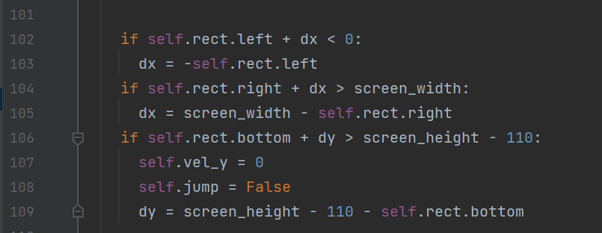

Now to add jumping for player I have add another variable in fighter class which is self.vel_y and the is the y velocity as I have the variable dy which is just how much I have to move player up and down but I also added velocity so I could know how fast is the player moving up and down. Y velocity is set 0 so the player doesn’t keep moving.



For jumping I have used key w for player one and up key for player 2. I have set the y velocity to negative 30 as negative in y direction moves up way. I have updated my dy here as for jumping and I have added the code (self.vel_y += gravity), which is going to bring down the y velocity every time because of the gravity.

To avoid player to jump continually while pressing the button longer I have added a trigger this trigger is added in the constructor first so when we first create the instance of the player, he is not in a jumping state so the variable is false.



I have added an additional check to this if statement when we long press w key the player won’t fly up. So, its going to avoid the double jump or continuous jump for this I have put jump to false so, as long we are not currently jumping then we can press the w key and we can jump as soon we have done this, we must set the self.Jump variable back to true.

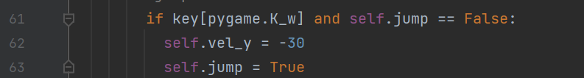

**Update player position:**

With the information I had updated the position of rectangle. As dx and dy variables are used to update the rectangles x and y positions.

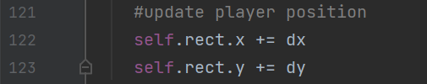

As to use this I have to call this move method with in the main game loop which is while command.



The screen width is defined here to control the player to remain on the screen as earlier mentioned so, it won’t give any error. The screen height is defined to make player on the bottom of the screen.

**Framerate:**

To do this I used clock variable and a variable for my framerate which is fps and is set to 60 frames per second

I had defined it in main loop as,

**ATTACK:**

Both players have two different attacks. As the assigned key is press the player attacks. For attack type one key r is press and for type two key t is pressed for player 1 and for player 2 keys are m and n. I have declared the variables in fighter class to 0.

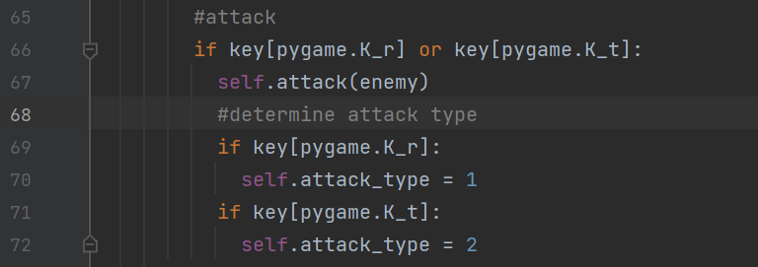

For the range of the attack, I have used four variables which are center x (so the attack is thrown from middle of the player) and y coordinate and height and width. To stop the attack form continuously happing I used trigger, so it attacks on time even in holding the key for long.

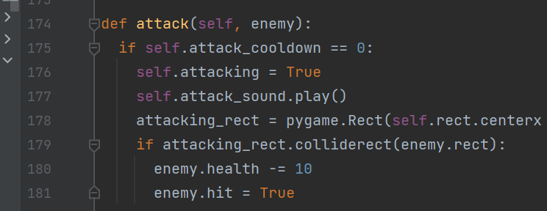

To make my players face each other I have used the code:

The variable flip is going to control which way the players are facing.

**Health:**

Both players have health of 100. The enemy’s health is going to drop by 10 every time when it gets an attack. For the health bar there are few variables assigned at first health player still has and then x and y coordinates where these two health bars are drawn. The health bar is a rectangle with green color and the rectangle itself is a coordinate of x and y with height and width. White color is used to know how much health is left and the blue color is the boundary of the health bar.

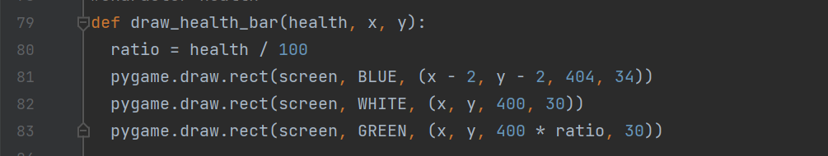

**SPRITE SHEETS:**

A sprite sheet is a single file that contains many smaller images, all are on plain or transparent background. Different frame when are shown quickly one after the other it gives the impression of animation. For knight is have one main sheet in which all the actions are so I had added one sheet rather then adding each action one by one in python list. The number of individual frames each of the animations have been important in sprite sheets. So, in the python list the numbers are the number of frames.

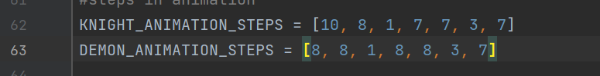

I have used different lists as they have different number of frames. To pass this code I had put the information in fighter instances by adding arguments in them. To determine how big will be the size of animation I have add up some information and data. So, I had created a list for data of both players.

As for each frame to get in the form of animation I have described the width and height and set up the list of images. Using for loop to go through each image in the main sheet and had made a list out of it. As x coordinate changes with each iteration of the for loop. As moving across the way need to move down the way too so I had nested the loop I have in side another for loop. Animation steps tells how many frames are in each sequence of the animation. For going vertically up and down I used variable y. I had y equals to zero and when each time the animation is complete y is increased by one. The empty list is the overall list that tracks all the animations going across the as well as going down the way.

**ACTION:**

Action is going the describe weather the player is idle, dead, jumping or whatever.

**Sprite animation:**

As to make each image from the main sheet to follow one after another I had set certain time by using ticks which is going to measure the time when the fighter was first created. It’s just like taking a timestamp at that instance.



Using update method which is always going to update the current image so it will going to determine which image of the frame or animation is going to shown on the screen. So, it is based on actions and the frame index. So ,I have increased the frame index and the animation is just going to run by itself. So, I have added a cooldown for this. As I had set the cooldown timer to 50 milliseconds so each animation frame is going to take half second once the time is run out it will move on to the next one. And makes the animation smoother. As I had set an animation sequence for the player actions such as 0 is idle, 1 is running, 2 is jump, 3 is attack and so on. As there are different number of sequences between idle and running has 8 frames so what happens is if I am in idle state and I am at frame index nine and if I try to change my animation to the next it doesn’t have nine frames so to avoid the error so I had used update action method and it takes new action as an argument so rather than just changing my self.action variable I had feed it through this method. The important thing is I had update the animation setting so I had reset the frame index so it can’t go from idle to run halfway through the animation. And same as the jump and attack and so on.

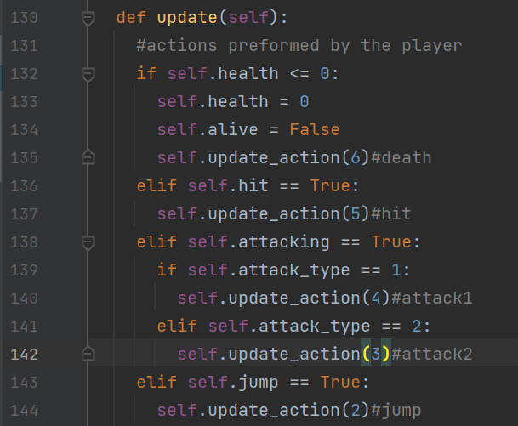

So, these actions are defining what player is doing in which state is he in.

**PLAYER:**

Player class is for identifying which controls are for which player is it player one or player two.

**Count:**

So, the game doesn’t start directly it starts with the countdown for 3.

It’s like what I did with the animations same I had taken the timestamp.